

**SATYUG KINDERGARTEN**

WG-11,Dharma Pura,Backside Naaz Shopping Complex , Near Civil hospital,Jalandhar city

Contact : 0181-4674670,7347060022 Email:satyugkindergarten@gmail.com

Student’s siblings details in case he/she is already a student of **SATYUG KINDERGARTEN**

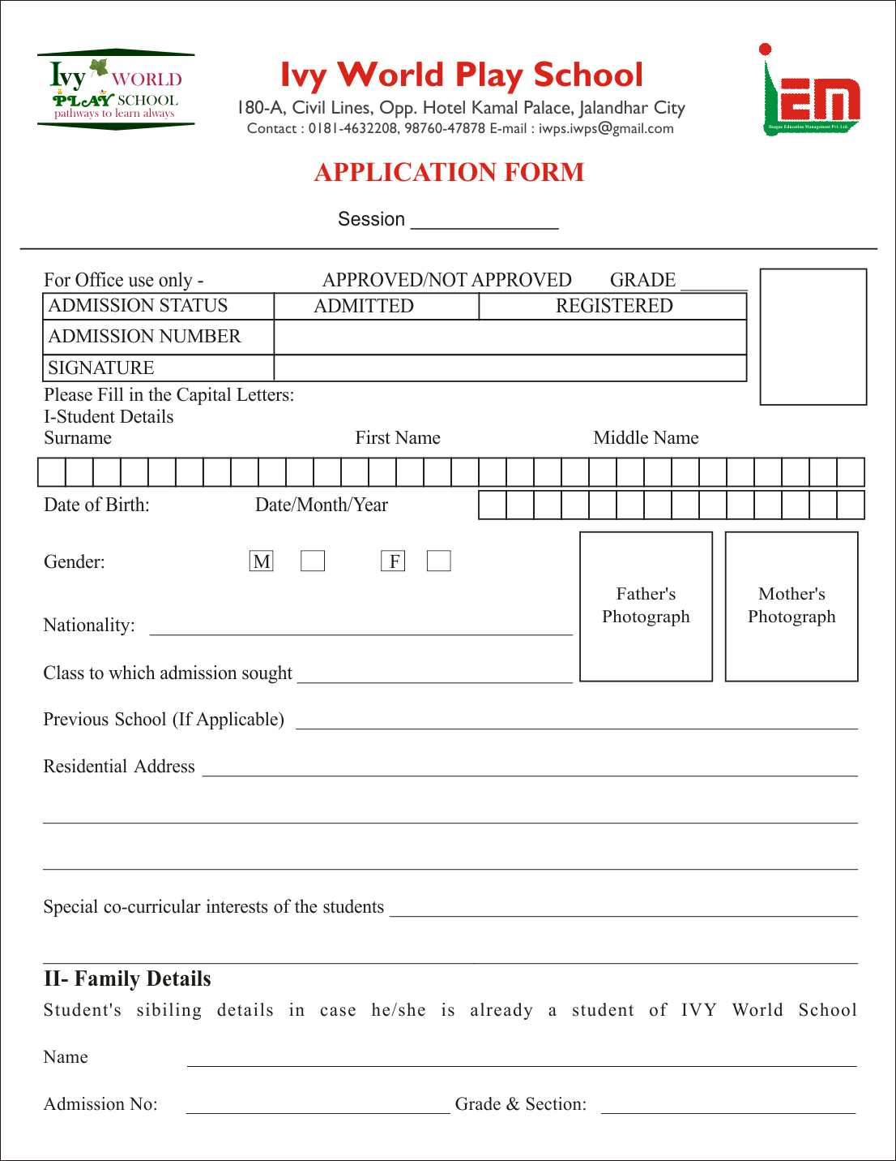

sg